Fiche n° 5
Installer un RSSEditor

Objectif :
Utiliser un "addon" de firefox (application qui s'intègre automatiquement au navigateur) spécialement consacré à la génération de fil rss

Bibliographie
https://addons.mozilla.org/fr/firefox/addon/344 ou sur la page d'accueil du projet http://rsseditor.mozdev.org/

D'autres addon de Firefox sur le rss : https://addons.mozilla.org/fr/firefox/tag/RSS

D'autres RSS editor
http://www.rss-info.com/en_rsseditor.html
Feed Writer 2 http://www.mirabyte.com/en/products/feedwriter/tutorials.html

Au 15 septembre 2009, le addon RSSeditor n'avait pas été rendu compatible avec la version 3.5 de Firefox et était resté à la version 3.0. A moins de descendre de version de firefox, ce qui est déconseillé, il est impossible de faire la démonstration, la seconde partie de la fiche est conservée pour mémoire.

On se penchera sur un exemple avec un autre outil, pas forcément un addon, mais un logiciel "standalone" : Rsseditor, qui se trouve sous http://www.rss-info.com/en_rsseditor.html

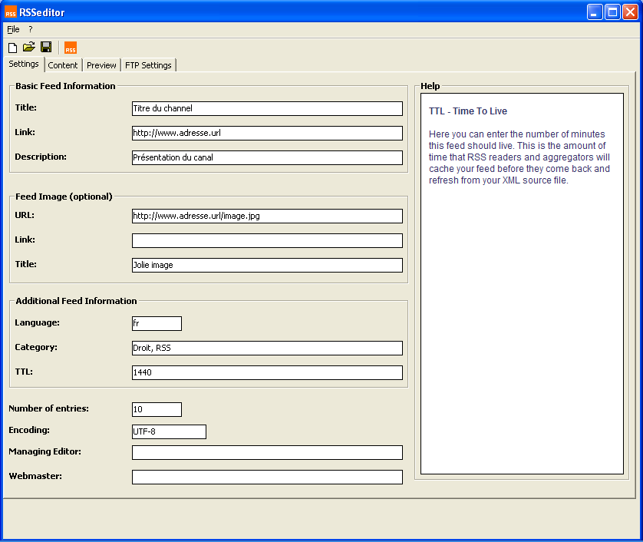

Ou bien sur Feed Writer http://www.mirabyte.com/en/products/feedwriter.html

(voir mode d'emploi en ligne ou à installer gratuitement sur http://www.mirabyte.com/en/products/feedwriter/download.html )

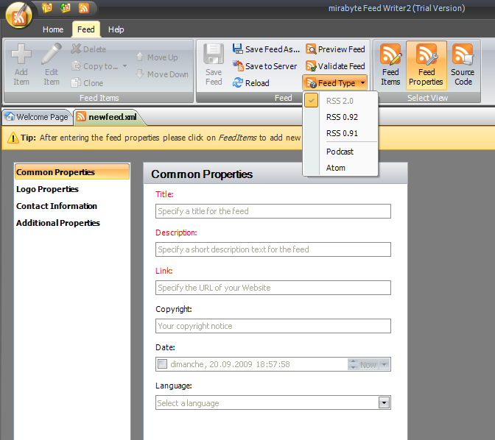
2e partie Addon RssEditor pour Firefox, pour mémoire

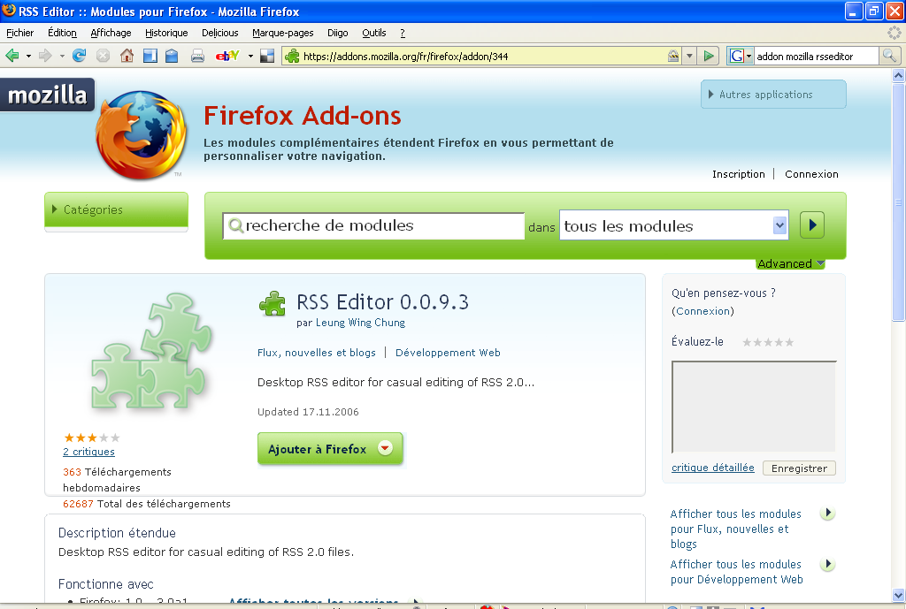

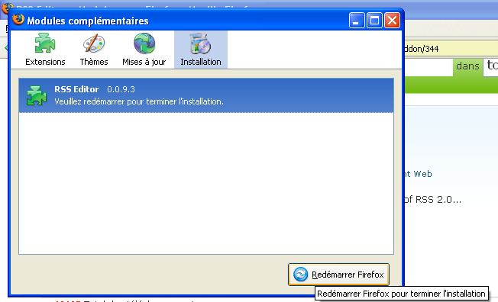
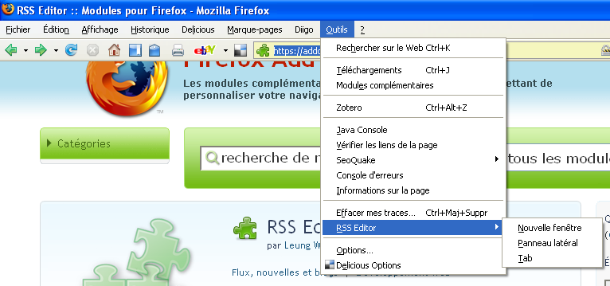

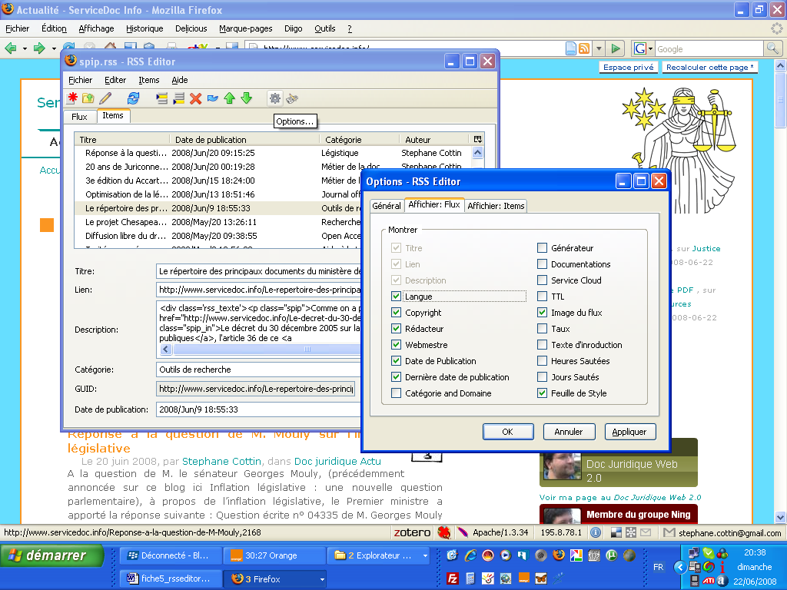

Quick Start

Here is a quick guide that you learn how to use RSS Editor. (If you are used to RSS, feel free to skip any of the steps below)

1. First, click on the Items Tab. The main functions of RSS Editor are built around there.
2. Then, add some items to the list. Use the Toolbar or the Items menu to do this.
3. Select an item from the list. Then type in (or paste) the title and the description.
4. The Publication Date is updated automatically. Enter more details if you wish.
5. You manipulate the items in the list using the Toolbar, the Items menu, or the Edit menu. Most of these functions are available as hotkeys. Try every function.
6. Now, go back to the Channel Tab to type something about the channel / news feed. To your pleasure, the Last Build Date is also updated automatically.
7. Press Ctrl-S to save the file. To avoid data loss, remember to save often!
Enjoy RSS editing!

Channel Tab
The channel tab is where you enter a brief description of the channel. Here is a list of the field supported by RSS Editor. The fields marked with an asterisk (*) is required, and the others are optional.

Field | Description | Example
Title* | Name of the RSS news feed. | mozdev - RSS Editor
Link* | URL of website that corresponds to the feed. | http://r.m.org
Description* | Description of the news feed. | The news from RSS Editor about new releases and updates to the web site.
Language | Main language used in the RSS feed. | en-US
Copyright Notice | Copyright notice for the content of the news feed. | © 2004 WC Leung
Managing Editor (e-mail) | The person responsible for editorial content, probably with an email address. | WC Leung <lwc@y.com>
Web Master (e-mail) | The person responsible for the technical details of the RSS news feed. | WC Leung <lwc@y.com>
Publication Date | The publication date for the content in the channel. This field should be filled by the Publish function when you publish your news feed.
Last Build Date | The last time that the content of the news feed is changed. Usually this is filled by RSS Editor automatically.
Channel Image | The URL of the image (or logo) that represents the channel. Default size of the image is 88px(W) × 31px(H), and the maximun size is 144px × 400px. | http://r.m.org/channel.png

Items Tab

The items tab is where you enter the items. Only one of the items marked with a sharp (#) (i.e. the Title or the Description) is required.

Field | Description | Example
Title# | The title of the item. | RSS Editor project launched
Link | URL of the item. | http://r.m.org/n/01.html
Description# | Description of the item.
Author | The author of the item. Can be left out if the author is the Managing Editor.
Category | Specifies one or more categories the item is in. Usually a space separated list. If you want hierachies it is common to use a "/" or ":" to be the divider. | RSS:news
RSS/news
GUID | Globally Unique Identifier, a randomly generated 128-bit string. RSS aggregators use GUIDs to uniquely identify news items. However, in most RSS feeds, GUID is a URL or a path (including a random string). | {f98feca3-ff1b-1129- b0e3-57c2fc654d0} RSS/news/a71f80fc
Publication Date | The publication date for the item. If set to future, it means the item is not published until the specified time. You can let RSS Editor to fill the date automatically.
Comments URL | The URL where you can give comments. Practically useless because comments are displayed with the news item at the same place.
Source | The feed title of the source feed, where the item is taken from. | mZine.org
Source Feed URL | The URL of the source feed, where the item is taken from. | http://mz.org/rss20.xml

